Mark Pratt

CST-247

7/16/20

Professor Pritchard

Activity 2 Part 3 Screenshots

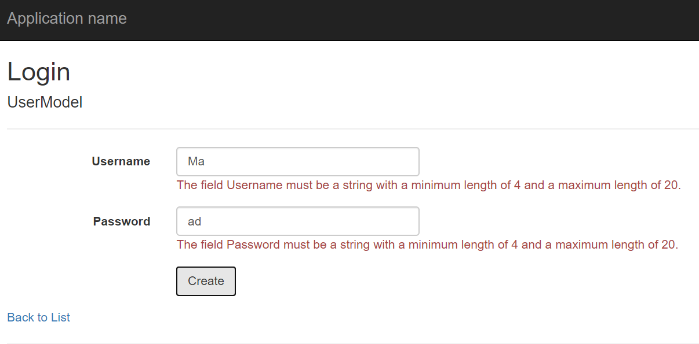

Screenshot 8

Login with validation errors

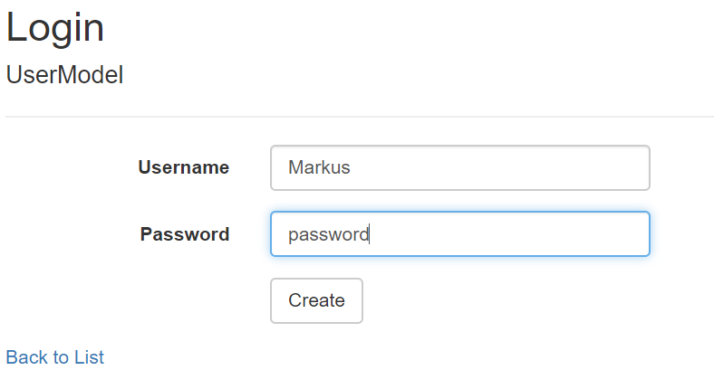

Screenshot 9

Login with successful validation